Chapter 16, Problem 36.

Refer to the circuit in Fig. 16.59. Calculate i(t) for t > 0.
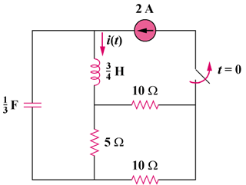
6(1–u(t)) A

Figure 16.59
For Prob. 16.36.

